Exp no:6 Determination and plotting of Capacitance of parallel plate capacitor in three different
dielectric medium with specific area, dielectric thickness and various dielectric constant.
Date:
Aim:
To write program for capacitance of parallel plate capacitor in three different dielectric media using
SCILAB.

Software required:
•SCILAB version 6.0.1
PROGRAM
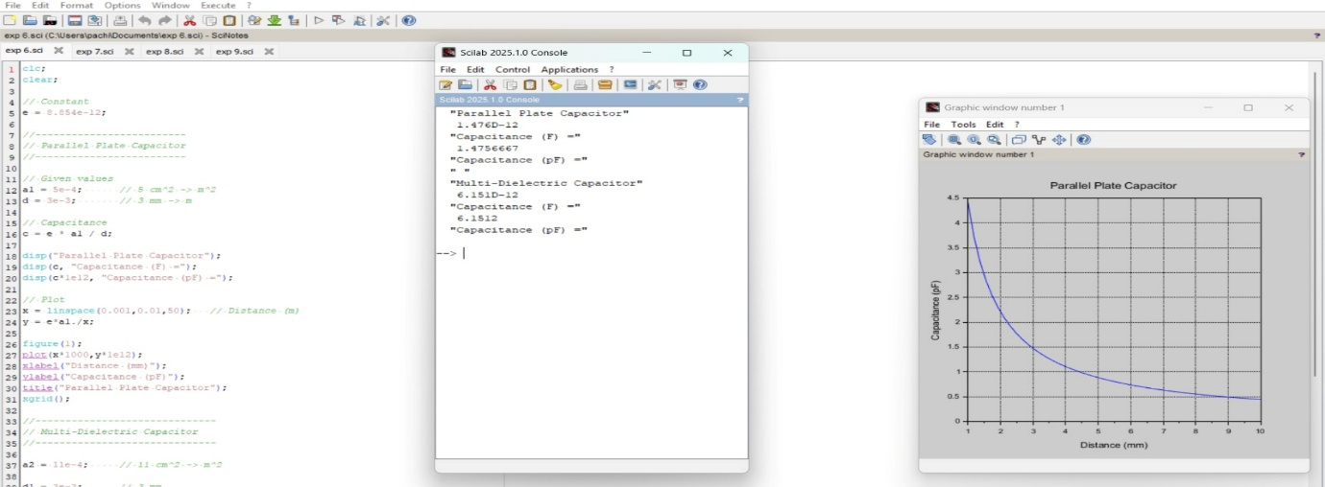
OUTPUT
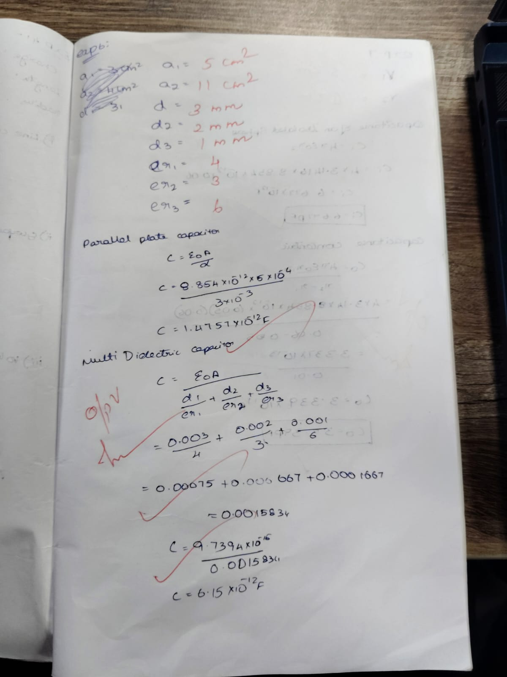

Case 1. AIR
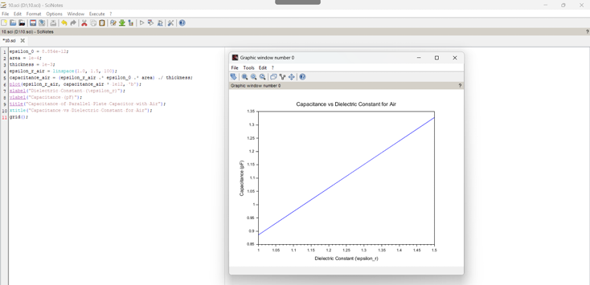
Case 2. Glass:
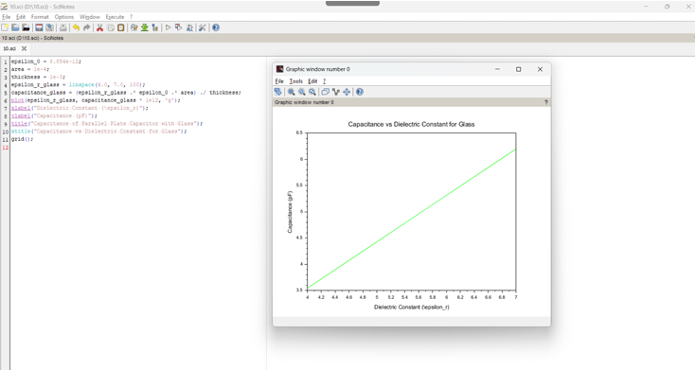

Case 3. Teflon:
